FBI Youth Leadership Academy

July 8-10, 2019

Learn, Do, Inspire

The FBI's Youth Leadership Academy is designed to promote an educational experience that will provide students with valuable leadership training and a greater understanding of the FBI. Through experiential learning activities, students will develop skills in communication, trust, team work, goal setting and leadership.

Bradford Woods:
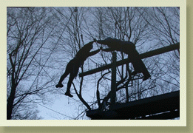

Is part of Indiana University, and is located just south of Mooresville, Indiana on State Road 67. Its 2,500 acres are dedicated to the enrichment and education of youth and adults from all over the world.

Who Can Participate?

We are seeking top-notch students from a variety of high schools in Indiana.

To be considered, students must:

~ have completed their junior year
~ have a GPA of at least 3.0
~ possess qualities of leadership, scholastic achievement and good citizenship;
~ commit to attending the entire program; and
~ write an essay of no more than 500 words depicting their interest in the program and how it will enhance their future plans.

For more information:
Kathryn Sipes
FBI Community Outreach Specialist
(317) 845-7035
kdsipes@fbi.gov

