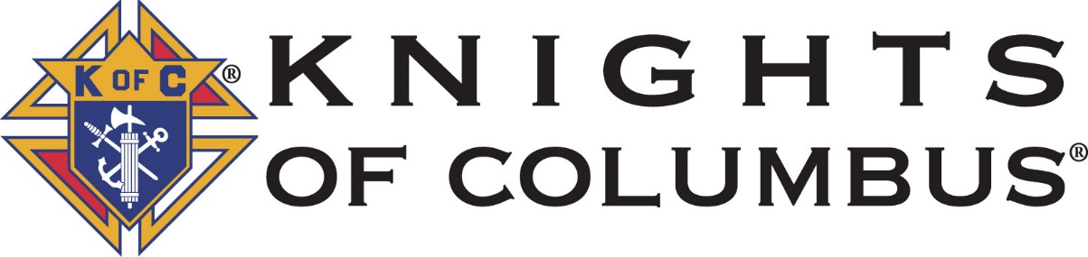
Councils 456 & 8056
2019 Free Throw Contest
(1/20/19 event Postponed Due to Weather)
New Date: January 27th, 2019 (Sunday)
Where: Central Catholic High School
Address: 2410 S. 9th Street, Lafayette, IN 47909
Time: Registration 1 pm, Contest starts at 1:30 PM
Eligibility: Boys and Girls from ages 9 thru 14
Requirement: Proof of Age for all contestants is required.
For more information please contact:
Rick Tolen: (765)-404-2777
Or Jim Cooley (765)-491-8317

