- April 19, 2018 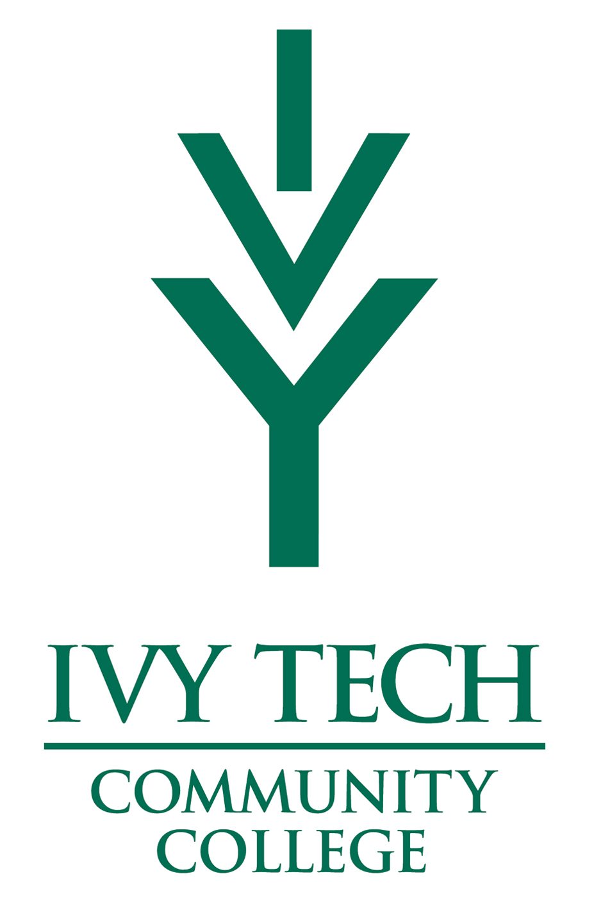  criminal justice day ivy tech – lafayette  Meet local, state and federal criminal justice agencies  Criminal Justice Day provides a unique opportunity for college students, high school law enforcement/JAG classes, dual-credit students and elementary students to meet with local, state, and federal criminal justice professionals in one location. Explore a wide-variety of careers while engaging in hands-on learning.  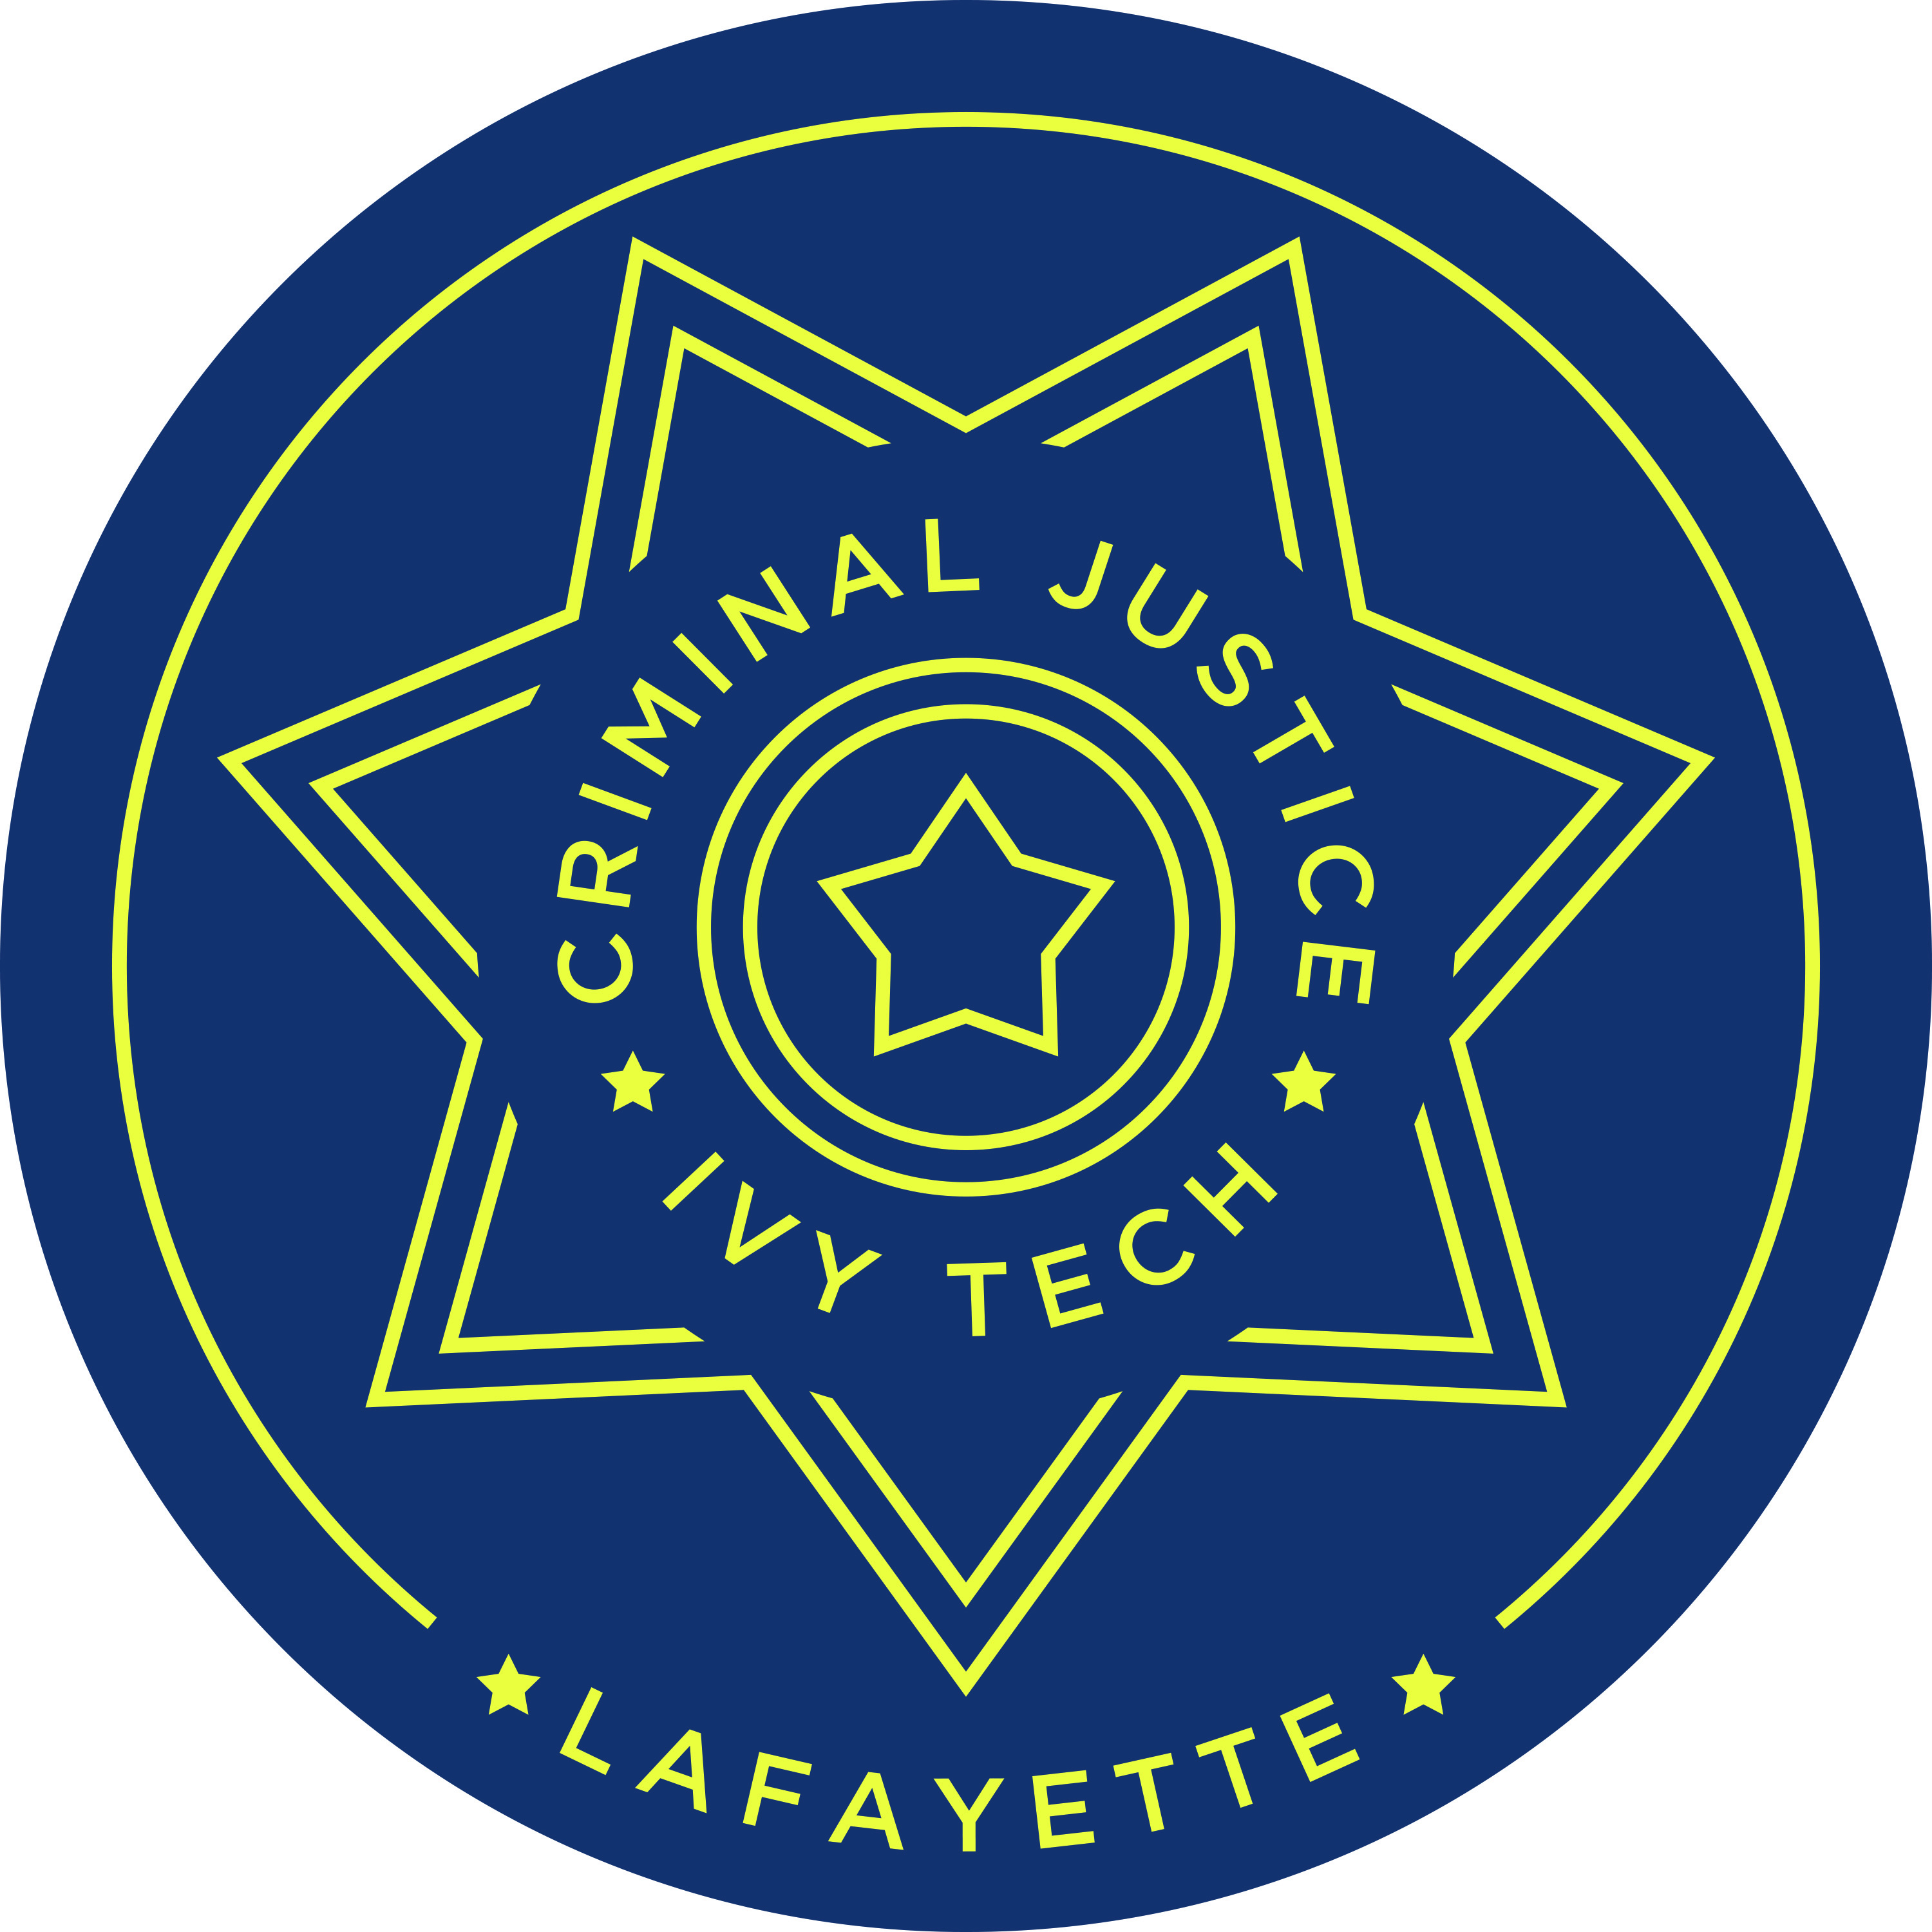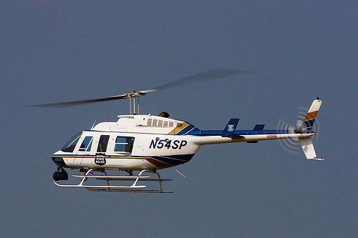 | What criminal justice field is right for you?  ____  K-9 Demonstrations  ____  Drone Demonstrations  ____  Child Fingerprinting  ____  All agencies in one location for one day!  Ivy Tech Community College  3101 S. Creasy Lane  Lafayette, IN 47905  765-269-5730  April 19th 9:00 AM - Noon

