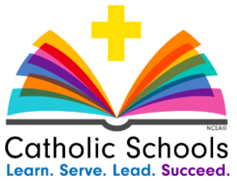

Central Catholic Jr./Sr. High School
Catholic Schools Week 2018

Sunday, January 28 Learn. Serve. Lead. Succeed: In Our Parishes
Opening Masses Celebrated at Lafayette/West Lafayette Parishes. Students who show pride in and gratitude for our schools by wearing their uniforms to Mass this weekend will receive a spirit day on Monday, February 12!

Monday, January 29 Learn. Serve. Lead. Succeed: In Our Communities
A regular schedule will be followed and uniforms should be worn. “Kiss the Pig” food drive - to benefit Tippecanoe County United Food Pantry - begins. Renew our commitment to pray for one another through #Prayer901.

Tuesday, January 30 Learn. Serve. Lead. Succeed: In Our Students
A regular schedule will be followed. Today students may wear jeans and sweatshirts - hoodies allowed today only! Students will participate throughout the day in a Catholic trivia game with prizes. Surprises from principals & ice cream treats from PACE will be shared! Food drive continues.

Wednesday, January 31 Learn. Serve. Lead. Succeed: In Our Schools
Students should arrive at CC in their all-school Mass uniforms. Family and friends are invited to join us for our LCSS Mass at 9:00 a.m. in McHale Gym. Canned food will be collected for the Tippecanoe County Food Pantry. After lunch students will have the opportunity to change and enjoy a little Afternoon R&R - playing games and watching movies.

Thursday, February 1 Learn. Serve. Lead. Succeed: In Our Vocations
A regular schedule will be followed and uniforms should be worn. In religion classes students will take part in activities in which they will explore and pray for vocations. Vocations stories will be shared on Schoology and our local priests, deacons, religious sisters and brothers will be in attendance and recognized at the varsity boys basketball game.

Friday, February 2 Learn. Serve. Lead. Succeed: In Our Faculty, Staff and Volunteers
Students will be dropped off at Mike Aulby’s Arrowhead for a morning of bowling and games (see info below). Students will be transported back to Central Catholic on school busses in time for lunch. Today is a CC spirit day. The afternoon will include a Service Extravaganza, Talent Show and finally a little roasting and a lot of appreciation for our teachers, staff and volunteers.

Friday, February 2: Bowling at Mike Aulby’s Arrowhead Bowl

We will begin the day at Mike Aulby’s Arrowhead Bowl for a morning of bowling, games, and more! Students who are normally dropped off at school will be dropped off at Mike Aulby’s between 7:30 – 8:00 am. Students who normally drive to school will drive to Mike Aulby’s. Administrators and teachers will be in the parking lot helping students with parking. Please follow the drop off procedure on the map below.

Everyone will be at Mike Aulby’s until 11 am. Students can bring money for games and the concession stand if they would like. At 11:00 we will begin transportation back to Central Catholic. We will use buses to transport all students, junior high students first, so they will be back at school for their lunch. If students drove to Mike Aulby’s, they will be dismissed to drive to Central Catholic by administration. Seniors will follow the directions given according to their permission slip (seniors only).

A map of Mike Aulby’s along with directions has been attached. If you have any questions please feel free to contact the school. We look forward to a wonderful week of celebrating Catholic Schools Week!

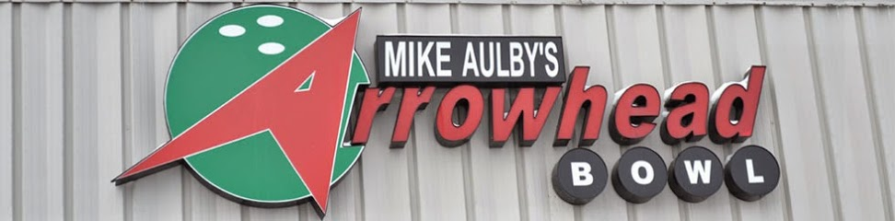

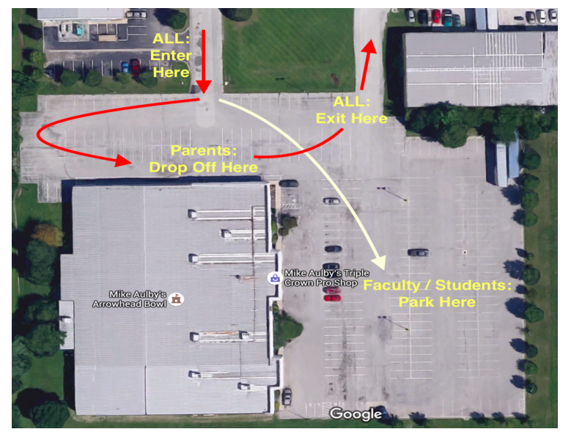

SERVICE PROJECTS for Catholic Schools Week 2018

Tippecanoe County United Food Pantry - Food Drive
Please send donated items Monday-Wednesday. Thank you for your generosity!

The Tippecanoe County United Food Pantry is operated by the Church Women United. It is located at North 14th Street and Tippecanoe Street, across from St. Elizabeth Central Chapel.
Items that are always needed:
- Non-perishable foods only
- Goods such as: tuna, soup, canned veggies, peanut butter, canned dinner i.e. Dinty Moore Stew.
- Paper products, toilet paper, paper towels, napkins.
- Condiments such as: garlic powder, chili powder, pepper, salt, ketchup, mustard, pickles, relish.
- Any kind of dessert mixes, cake, brownies, cornbread.
Important:
- Our clients do not always have refrigerators or ovens.
- They may not have eggs, so they may not be able to use mixes or keep food cold.
Volunteers are Needed: If you want to volunteer all you do is show up during these hours:
- 11:30 to 3:00 Monday through Wednesday
- 3:30 to 6:00 Thursday only

WHICH TEACHER DO YOU WANT TO KISS A PIG? This year the food drive will be a competition organized by our Senior High Student Council. Students will place their donations on the table of the teacher or administrator whom they want to see KISS A PIG!

SERVICE EXTRAVAGANZA!
All students will have the opportunity to take part in a variety of service activities on Friday during the lunch hour in McHale Gym. If you have a service activity that you would like to share, contact Mrs. Justak!

Some of the Service Activities include:
- AMERICAN RED CROSS - assembling Comfort Kits for those affected by natural disaster.
- FOOD FINDERS FOOD BANK - preparing packaging for bulk item distribution.
- LAFAYETTE URBAN MINISTRY SHELTER - assembling Care Packages for local homeless men and women.
- BLANKETS FOR PATIENTS - making no-sew fleece blankets for patients and their families at St. Elizabeth Hospital, organized by parent, Erin Albregts.
- EASTER CARDS FOR ELDERLY - making cards for elderly and homebound men and women, distributed by the Sisters of St. Francis of Perpetual Adoration.
- VALENTINES FOR VETERANS - making cards for men and women currently serving in the military as well as those veterans living at the Indiana Veterans’ Home.
- Do you have a service activity to share with our students and community? Contact Jodi Justak at jjustak@lcss.org.

