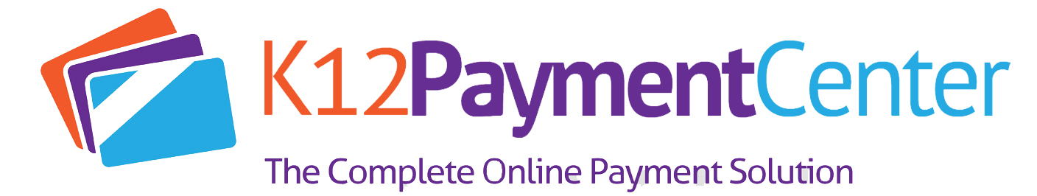
Online Payment Email Template to Parents
Dear Parents,
Dealing with your children’s school money just got a lot easier! You can now add money to their accounts for meals, pay for school-related fees online securely and even see what they are buying.
You may have previously used www.K12PaymentCenter.com to access your child’s meal account, but now the website is new and improved, with more features that make it easier to manage your child’s account. You can now pay for school fees like merchandise, apparel, supplies, tickets, yearbooks and more online. You’ll even receive email and text notifications when school fees are assigned to your student.

If you already have an online payment account, just login with your current login credentials. All of your information will be transferred over. If you haven’t used the website before, go to www.K12PaymentCenter.com and click “Register Now” to create an account. Select Lafayette Catholic School Systems from the drop-down lists of school districts, fill in your information, input your credit or debit card information and you’re ready to go! Note that you will need your child’s student ID number; simply contact us for their ID number and with any other questions you may have.
Online Payment Website Facts:
- Make payments for meals and school fees online securely using your credit card
- Have more than one child in the district? You can deposit money into multiple accounts with just one payment!
- You get quick and easy access to your child's account 24 hours a day, seven days a week
- The ability to:
  - see 120 calendar days of purchases and payments
  - Check your child’s meal account balance
  - Get low balance alerts by e-mail and text
- Pay for not only school meals but school fees, such as merchandise, apparel, supplies, tickets, yearbooks, etc.
- Receive email and text notifications when school fees are assigned to your student
- Less hassle and no more “lost lunch money” or sending checks into the district office
- Setup monthly or weekly recurring payments
- Peace of mind, knowing exactly what you money is being spent on
- You can access online payments on Facebook
- There are no banners, pop ups ads or advertising
- We do not share any information with third parties, other than your financial institution and your child's school
- The website is secure site and utilizes all of the current industry privacy standards
For more information, go to www.K12PaymentCenter.com or call the Dining Service Director, Ellen Sipes, at 765.607.4925.

Click here to see a video on how to start managing your child’s account online today!

